

**Touchstones**

***Netcards***

**God / The Divine Netcards with Text**

Ark of the Covenant HRJ

Baby HRJ

Believe HRJ

Bread HRJ

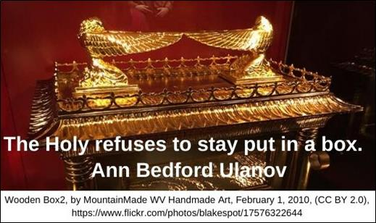

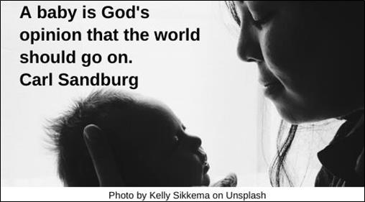

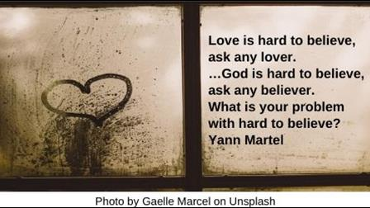

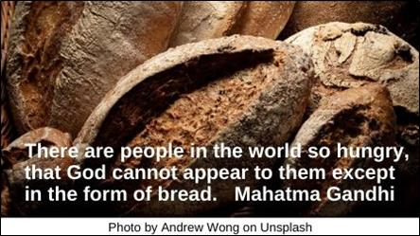

Cat HRJ

Church HRJ

Committee HRJ

Dice HRJ

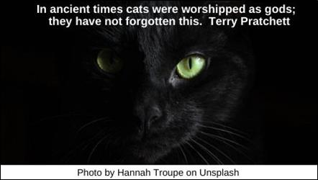

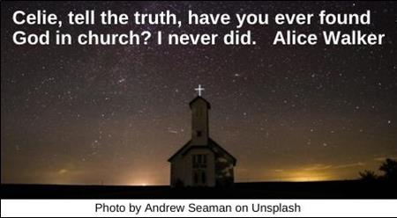

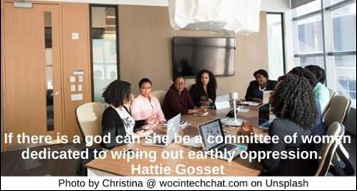

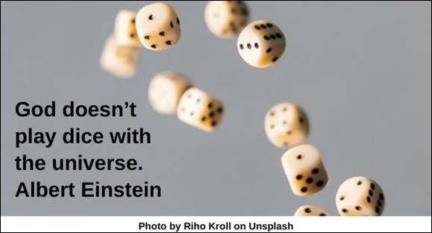

Eye HRJ

God Concept HRJ

Hate Speech HRJ

Hatred HRJ

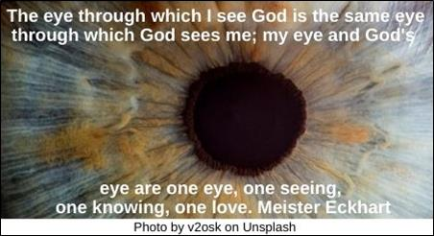

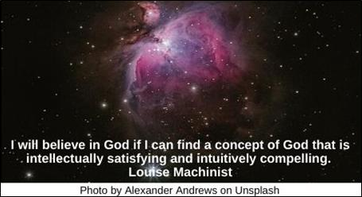

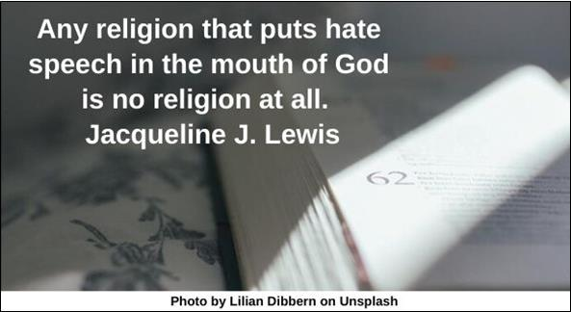

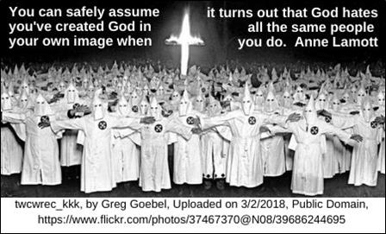

Hell HRJ

Music HRJ

Neat Lines HRJ

No Consolation HRJ

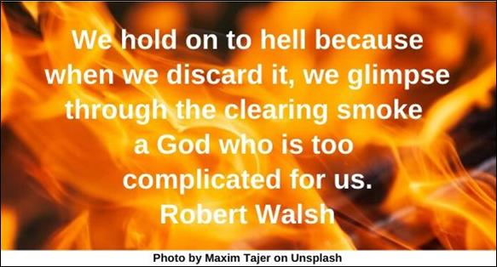

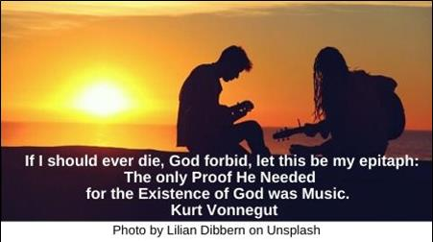

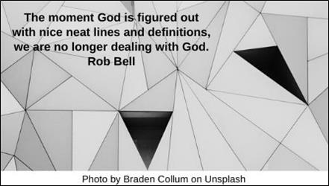

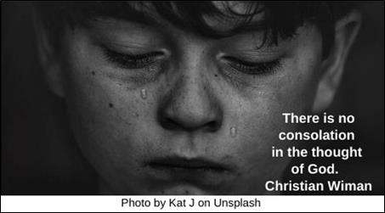

No Religion HRJ

Pottery HRJ

Prayer HRJ

Purple HRJ

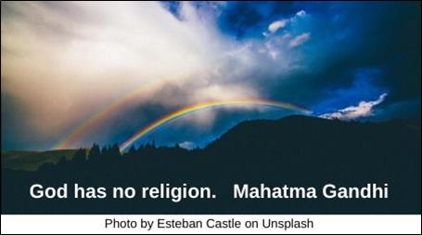

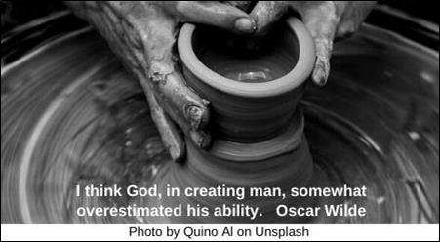

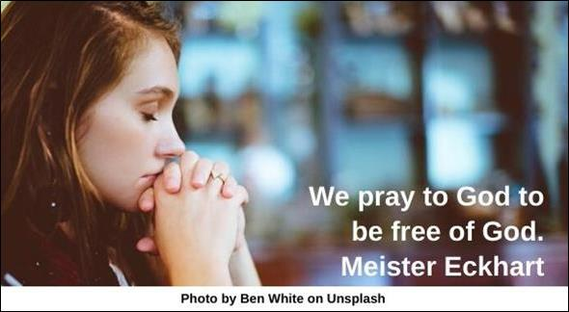

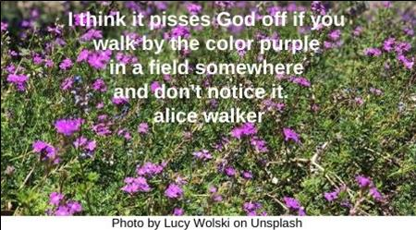

Remember HRJ

Rose in Winter HRJ

Silence HRJ

Singing HRJ

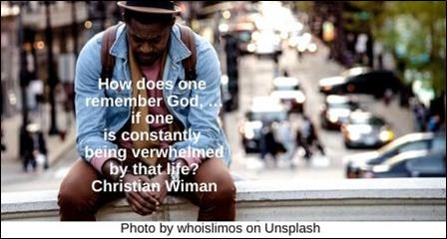

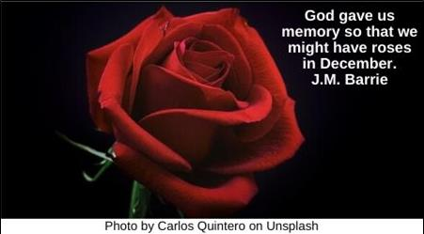

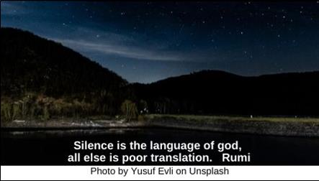

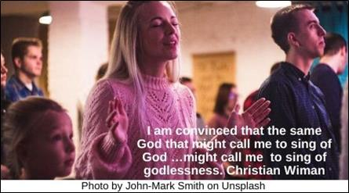

Storm HRJ

Tears HRJ

Thank You HRJ

Tree HRJ

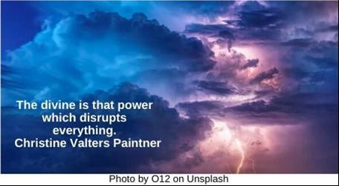



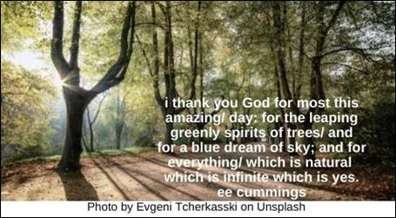



Unbelief HRJ

Work HRJ

World HRJ

Worship HRJ

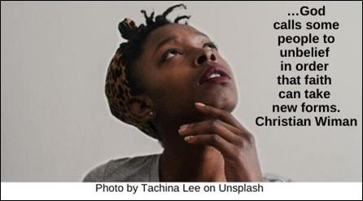

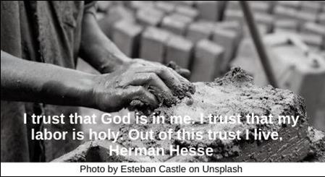

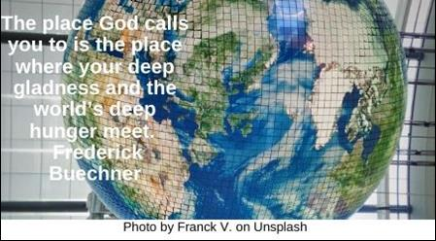

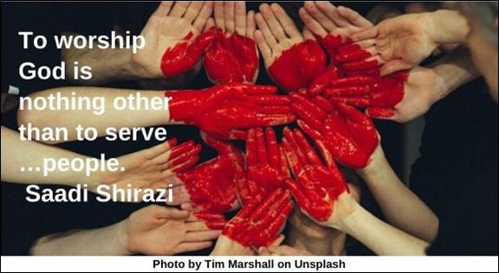

**Text of Quotes**

Ark of the Covenant

The Holy refuses to stay put in a box.

Ann Bedford Ulanov

Baby

A baby is God's opinion that the world should go on. Carl Sandburg

Believe

Love is hard to believe, ask any lover. …God is hard to believe, ask any believer. What is your problem with hard to believe? Yann Martel

Bread

There are people in the world so hungry, that God cannot appear to them except in the form of bread. Mahatma Gandhi

Cat

In ancient times cats were worshipped as gods; they have not forgotten this.

Terry Pratchett

Church

Celie, tell the truth, have you ever found God in church? I never did. Alice Walker

Committee

If there is a god can she be a committee of women dedicated to wiping out earthly oppression. Hattie Gosset

Dice

God doesn’t play dice with the universe. Albert Einstein

Eye

The eye through which I see God is the same eye through which God sees me; my eye and God's eye are one eye, one seeing, one knowing, one love. Meister Eckhart

God concept

I will believe in God if I can find a concept of God that is intellectually satisfying and intuitively compelling.

Louise Machinist

Hate Speech

Any religion that puts hate speech in the mouth of God is no religion at all. Jacqueline J. Lewis

Hatred

You can safely assume you've created God in your own image when it turns out that God hates all the same people you do. Anne Lamott

Hell

We hold on to hell because when we discard it, we glimpse through the clearing smoke a God who is too complicated for us.

Robert Walsh

Music

If I should ever die, God forbid, let this be my epitaph: The only Proof He Needed for the Existence of God was Music.

Kurt Vonnegut

Neat Lines

The moment God is figured out with nice neat lines and definitions, we are no longer dealing with God. Rob Bell

No Consolation

There is no consolation in the thought of God. Christian Wiman

No Religion

God has no religion. Mahatma Gandhi

Pottery

I think God, in creating man, somewhat overestimated his ability. Oscar Wilde

Prayer

We pray to God to be free of God.

Meister Eckhart

Purple

I think it pisses God off if you walk by the color purple in a field somewhere and don't notice it. Alice Walker

Remember

How does one remember God, …if one is constantly being overwhelmed by that life? Christian Wiman

Rose in Window

God gave us memory so that we might have roses in December. J.M. Barrie

Silence

Silence is the language of god, all else is poor translation. Rumi

Singing

I am convinced that the same God that might call me to sing of God …might call me to sing of godlessness. **Christian Wiman**

Storm

The divine is that power which disrupts everything. Christine Valters Paintner

Tears

Even when the gates of heaven are shut to prayer, they are open to tears. The Talmud

Thank you

i thank you God for most this amazing/ day: for the leaping greenly spirits of trees/ and for a blue dream of sky; and for everything/ which is natural which is infinite which is yes. ee cummings

Tree

Not that I want to be a god or a hero. Just to change into a tree, grow for ages, not hurt anyone. Czesław Miłosz

Unbelief

…God calls some people to unbelief in order that faith can take new forms. Christian Wiman

Work

I trust that God is in me. I trust that my labor is holy. Out of this trust I live.

Herman Hesse

World

The place God calls you to is the place where your deep gladness and the world’s deep hunger meet. Frederick Buechner

Worship

To worship God is nothing other than to serve …people. Saadi Shirazi